**Lab 2: *Eclipse*-ing It**

Welcome to Lab 2!

In this lab, we are going to set up our development environment so we can start looking at and writing code!

**Part I: Getting Ready in *Install*-ments**

**Install Java**Because we will be developing our Alexa Skills in Java, we need to download the JDK (Java Development Kit), which provides a development environment for building applications using the Java language.

1. Go to Oracle’s [JDK Download page](http://www.oracle.com/technetwork/java/javase/downloads/jdk8-downloads-2133151.html)
2. Accept the license agreement for the Java SE Development Kit 8u144
3. Click the download link corresponding to the OS you are running. For example, I clicked the link next to Mac OS X.

For Windows, check which OS you are running (32- or 64-bit), and click on the corresponding link. I am running Windows 10 64-bit, so I clicked on the link highlighted below.

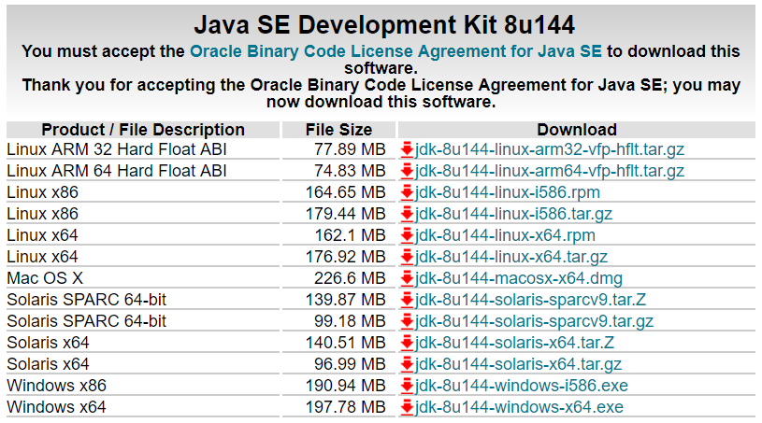

1. If you’re using a Windows machine, you will need to set environment variables to use java and javac
   * Right click **Computer**
   * Click the **properties**
   * On the left pane select **Advanced System Settings**
   * Select **Environment Variables**
   * Under the **System Variables**, Select **PATH** and click **edit**, and then click **new** and add path as **C:\Program Files\Java\jdk1.8.0_131\bin** (*depending on your installation path*) and finally click **ok**
   * Next restart your command prompt and open it and try typing in *javac*

See this [link](https://stackoverflow.com/questions/32241179/setting-up-enviromental-variables-in-windows-10-to-use-java-and-javac) for more info.

**Install Maven**

Next, we need to install Maven, a build automation tool that will compile our source code into binary code as well as package it so that we can upload it to AWS Lambda (more on this later).

**Instructions for Mac OS X:**

1. Go to <http://maven.apache.org/download.cgi> and download Maven by clicking the link for the “Binary tar.gz archive” file:  
   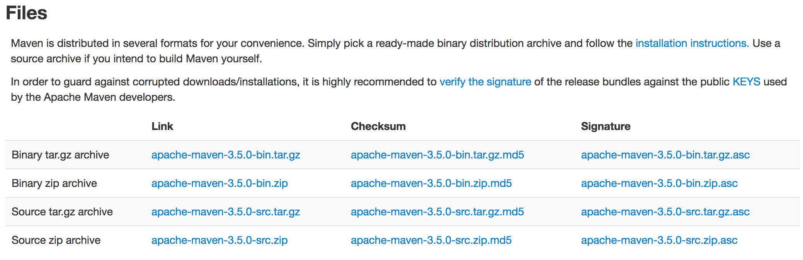
2. Open up Finder, and move the downloaded tar file to your Home directory; for example, /Users/shingorani
3. Open up Terminal and navigate to the directory with your Download.
4. Extract it using the following command. You may need to adjust the version in the command depending on which version you downloaded.

tar -xvf apache-maven-3.5.0-bin.tar

1. **Set Maven command in environment variable.**  
   We need to update the ~/. bash_profile file. If the file doesn’t exist, we want to create it. We can do this with the following command:

$ vim ~/.bash_profile

1. Add the following lines to this file:

* Type ‘i’ to insert lines
* Copy and paste the following lines into the file:

export M2_HOME=/Users/shingorani/apache-maven-3.5.0

export PATH=$PATH:$M2_HOME/bin

1. Press the escape key and type “:wq” to save the changes to the file
2. Restart the terminal. Test to see maven is working using the following command:

$mvn -version

You should see output similar to what follows:

Apache Maven 3.1.1 (0728685237757ffbf44136acec0402957f723d9a; 2013-09-17 23:22:22+0800)

Maven home: /Users/mkyong/apache-maven-3.1.1

Java version: 1.7.0_05, vendor: Oracle Corporation

Java home: /Library/Java/JavaVirtualMachines/1.7.0.jdk/Contents/Home/jre

Default locale: en_US, platform encoding: UTF-8

OS name: "mac os x", version: "10.9", arch: "x86_64", family: "mac"

**Instructions for Windows 10:**

1. Go to <http://maven.apache.org/download.cgi> and download Maven by clicking the link for the “Binary zip archive” file:  
   
2. Open up Windows Explorer, and unzip the download to a local folder, for example: c:/maven
3. Edit Environment Variables for your system: Add into “Path”: C:\maven\bin.
4. Add new System variables “JAVA_HOME”, with value of your jdk installation path, be careful not to include the “bin” in the path here  
   For example: Variable name: JAVA_HOME  
   Variable value: E:\Programs\java\jdk1.8.0_45
5. Open the Command Prompt console, and type “mvn -v” to test if the maven installation was successful

**Install Eclipse**Eclipse is the IDE (Integrated Development Environment) we will be using to develop our applications. This will provide a source code editor and integration with Maven’s build automation tools.

**Instructions for Mac OS X:**

1. Go to [Eclipse's Download page](http://www.eclipse.org/downloads/packages/eclipse-ide-java-developers/oxygenr)
2. Download Eclipse for Mac OS X (Cocoa) 64-bit
3. Once the download completes, double click to open in Finder.
4. Click and drag Eclipse on to the Applications shortcut in the folder.
5. Open the Eclipse application.
   1. If it tells you Eclipse has been downloaded from the internet, click “Open anyway.”

**Instructions for Windows 10:**

* Go to [Eclipse's Download page](http://www.eclipse.org/downloads/packages/eclipse-ide-java-developers/oxygenr)
* Download Eclipse for Windows 32-bit or 64-bit (depending on which version you are running)
* Once the download completes, open in Windows Explorer and right click 🡪 Extract All
* Then navigate to the executable file (eclipse.exe) and double click to open Eclipse
* You may wish to pin the application to the taskbar (right click eclipse.exe and click “pin to taskbar”)

**Part II: *Git*ting Access**

Now that we have Java and Eclipse installed, we are ready to start looking at some code! In order to do this, we need access to a Git repository.

1. Log into [GitHub](https://github.com/).
2. If you haven’t already done so in Lab 1, fork the [mson-team-alexa/alexa-skills-kit](https://github.com/mson-team-alexa/alexa-skills-kit-java) repository into a repository of your own by clicking “Fork” in the upper right corner.  
   
3. Then select your own username for “Where should we fork this repository?” (Skip this step if you already forked before.)  
   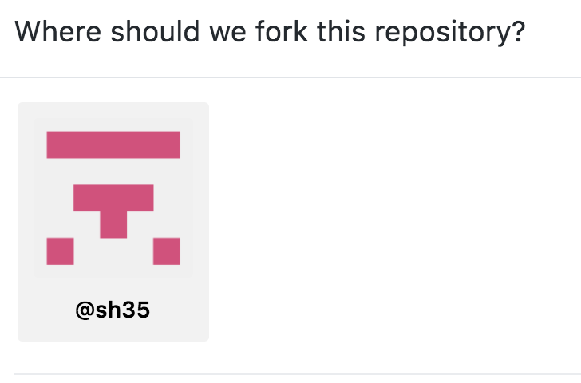
4. Open up GitHub Desktop.
5. Click the “+” in the upper left corner, then select “Clone” and the name of the repository we just forked: alexa-skills-kit-java. (Skip this step if you already forked before.)  
   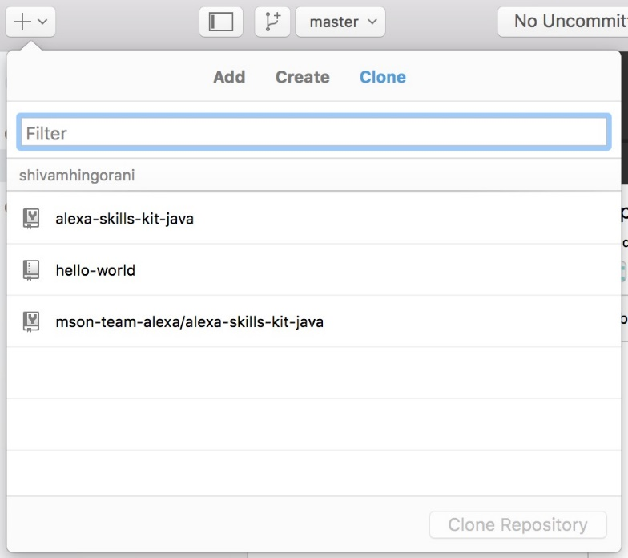
6. Right click on the repository name within GitHub and select “Open in Terminal” (on Mac) or “Open Command Prompt” (on Windows)

Note: If you are prompted with the message “Unable to locate Git” this means you need to install Git (click “Install Git” and follow the instructions)  
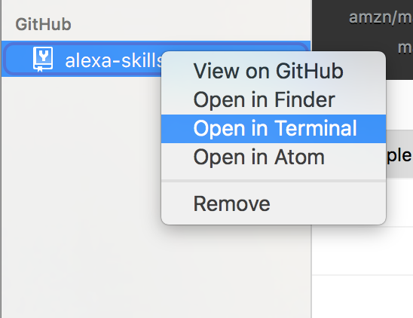

1. Once Terminal opens up, it should already be in the correct directory (that of your local copy of the repository). Now copy and paste the following command into Terminal to build the Maven project, so we can open it in Eclipse.

mvn assembly:assembly -DdescriptorId=jar-with-dependencies package  
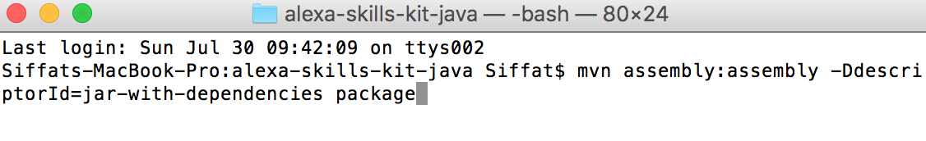

1. You should see the build complete with a message like this.  
   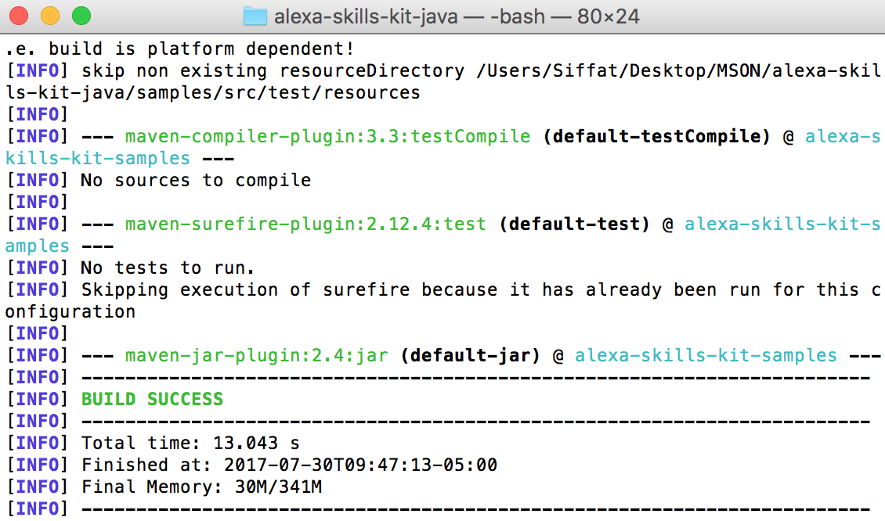
2. Now open Eclipse.
3. Select File 🡪 Import.  
     
   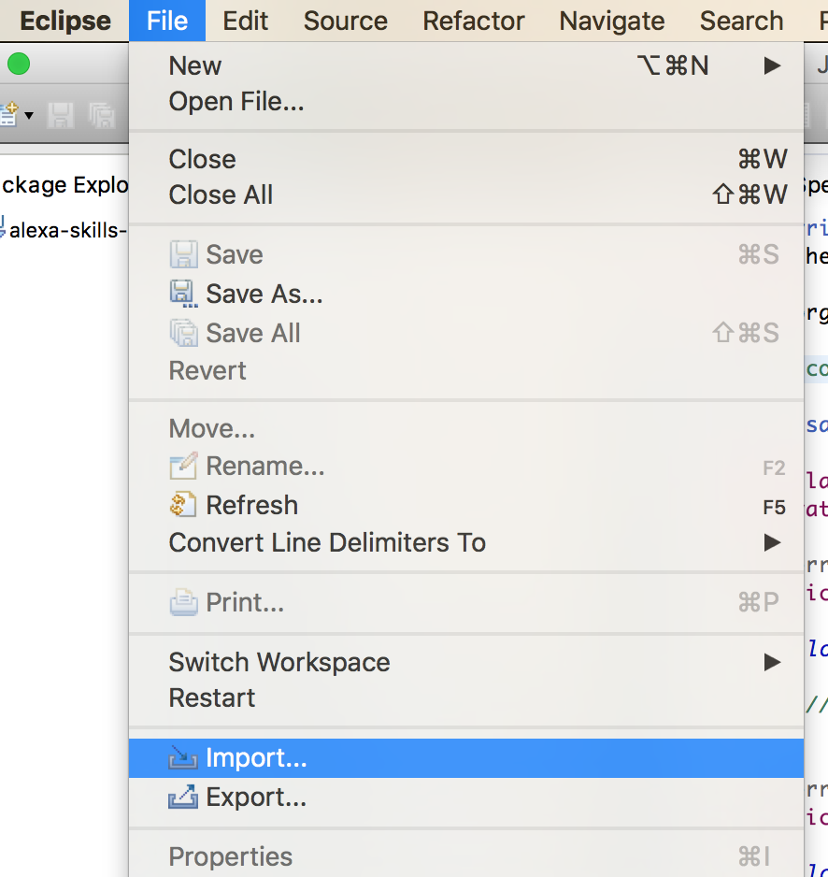
4. Expand “Maven” and then select “Existing Maven Projects” and click “Next.”  
   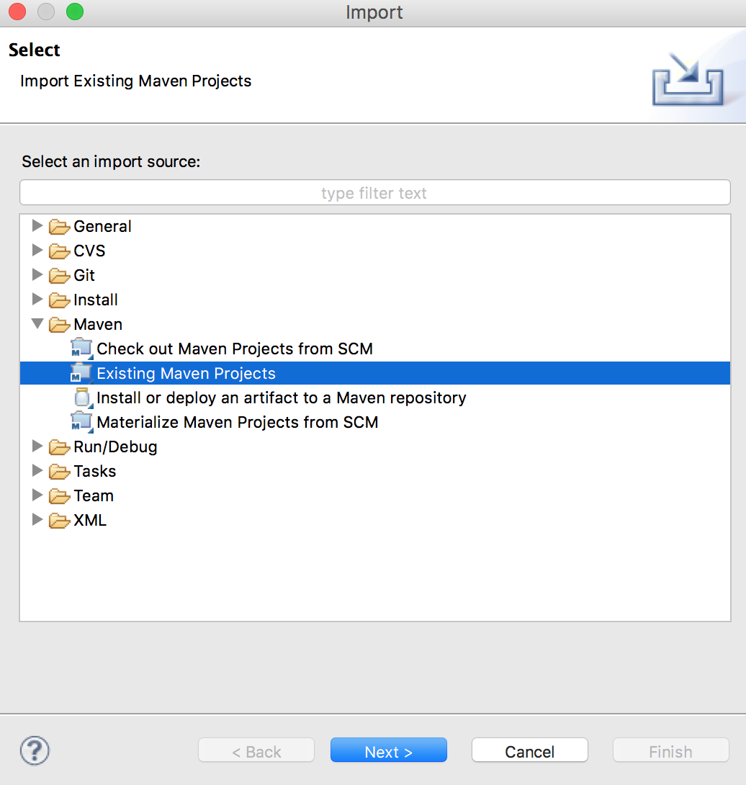
5. Next to Root Directory, click “Browse” and navigate to your local root directory for the alexa-skills-kit repository.

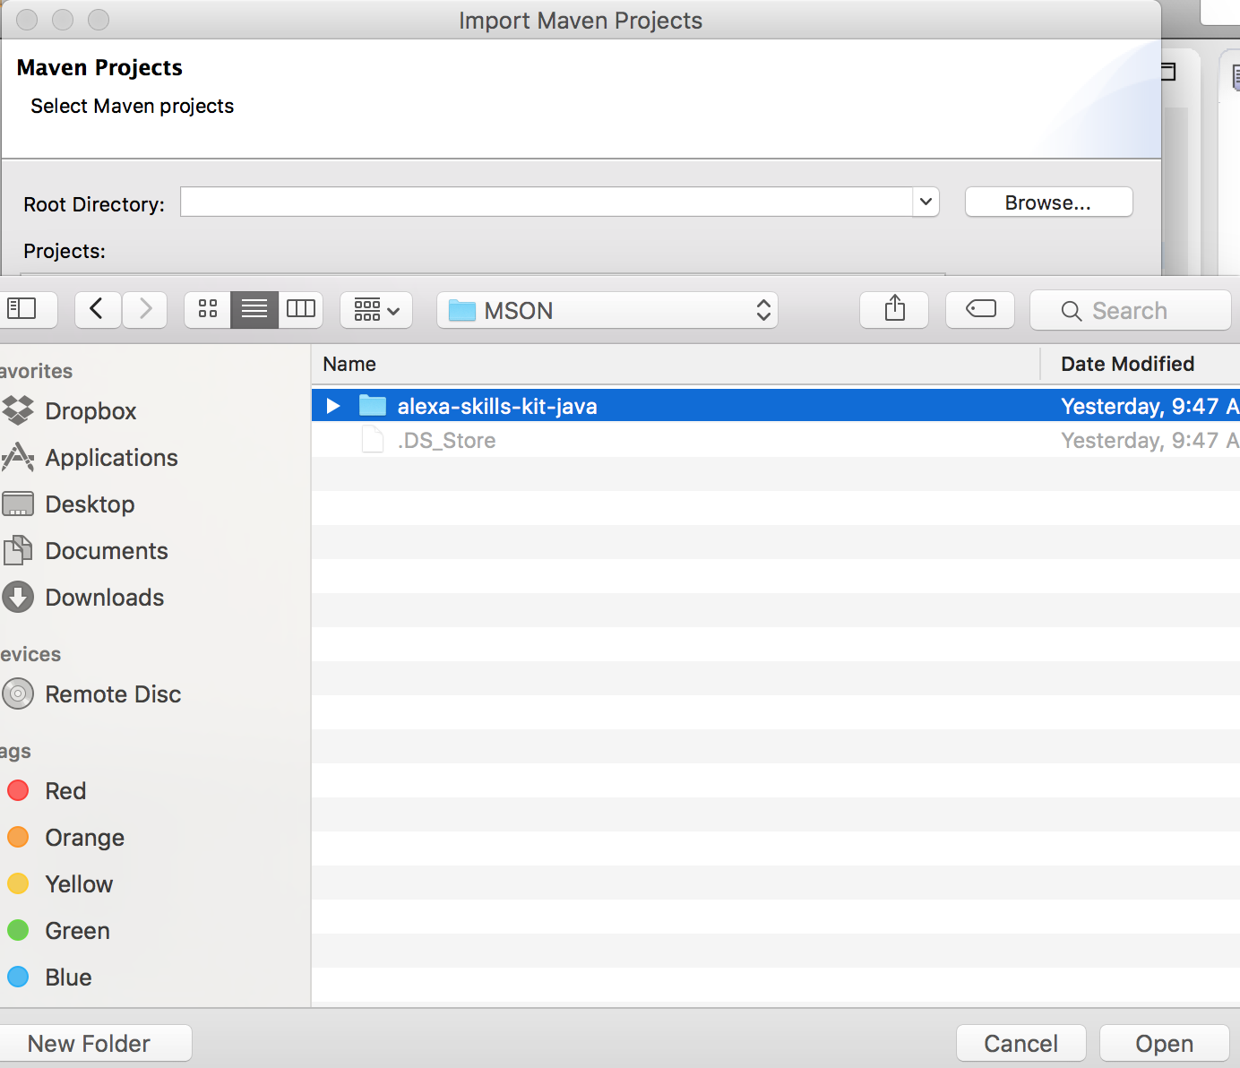

1. Finally click “Finish.”  
   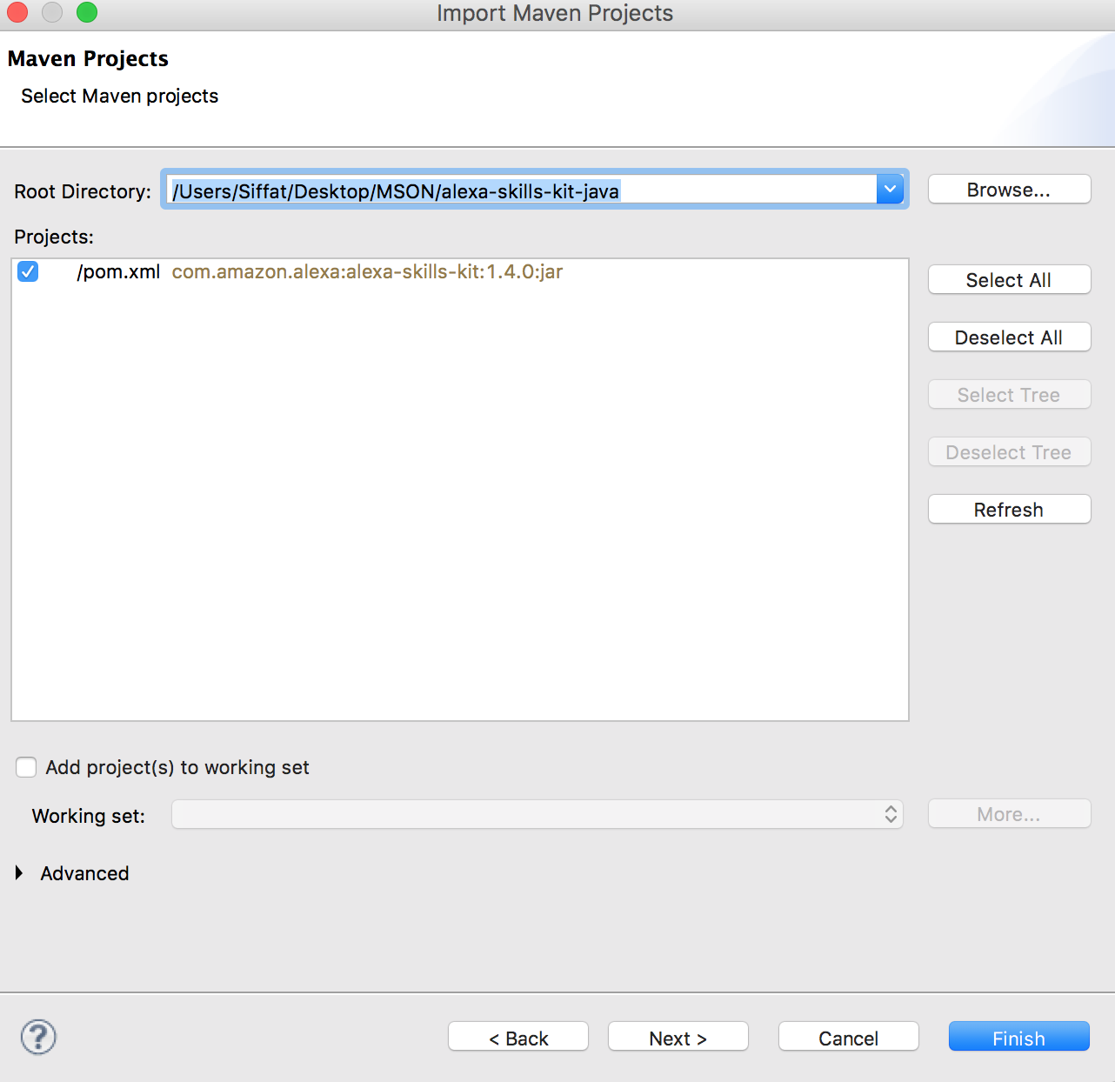
2. You should see the contents of the repository in Package Explorer (left pane). You may need to close the “Welcome” tab to see this.  
     
   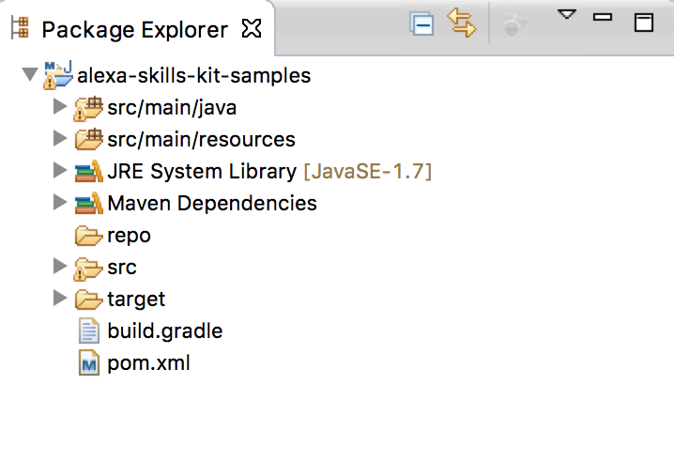

**Congratulations!** You have successfully completed Lab 2!